YD 180 AL

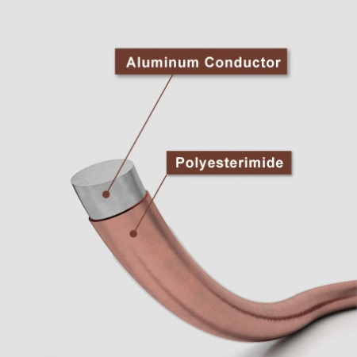
Model:

QZYL/180, EI/AIWA/180

Description:

YD 180 AL, is polyesterimide enamelled aluminium wire belonging in H (180°C) thermal class, able to be manufactured in the diameter range of 0.20 – 3.66 mm. Provides advantage due to the low density of aluminum in cases where weight is more important than volume.

Available:

Providing thermal resistance up to 180 °C, YD 180 AL offers ease of winding due to the flexible enamel layer coated on soft conductor.

Fields of Use:

- Contactor
- Magnetic coils
- Relays
- Transformer
- Small motors
- Ballast

Advantage:
- All products parameters are recorded with quality control system at every stage of production process and following by barcode system until delivery.
- Our products receive approval with production parameters of quality control system according to standards of GB/T23312.7 2009, IEC60317-25, NEMA 35.

Thermal Class (°C) | Class H, 180 °C
Insulation | Base Coat | Polyester-imide
Insulation | Top Coat | -
Insulation | Bong Coat | -
Production Range (MM) (MM) | 0.20 - 3.66 mm
Certification I.E.C | IEC 60317 - 15
UL File No.
Class Temperature (°C) | 180 °C
Heat Shock (°C) | ≥ 200 °C
Cut Through Temperature (°C) | ≥ 320 °C
Solderability (°C) | Non solderability
Bonding Temperature (°C) | Not Applicable
Re-softening Temperature (°C) | Not Applicable
Normal Solvent Resistance | 3H-4H
Resistance to humidity | Excellent
Resistance to Impregnants | Yes
Resistance to Refrigerants | Yes
Distinct Features | Generator, Motors, Transformers

